  [](http://opensource.org/)

® The OSI logo trademark is the trademark of Open Source Initiative.

**Linux Kernel Hack Challenge**  
Linux Kernel Hack Challenge is a contest to encourage Linux professionals to solve an execution time measurement problem. The winner solution will be awarded with a flight in a SAAB Gripen simulator including travel to Linköping, and accommodation.

The task is to provide a Linux kernel modification that gives a more accurate worst-case execution time measurement taking into account cache effects. The winning solution may be used to verify execution time aspects of airborne software.

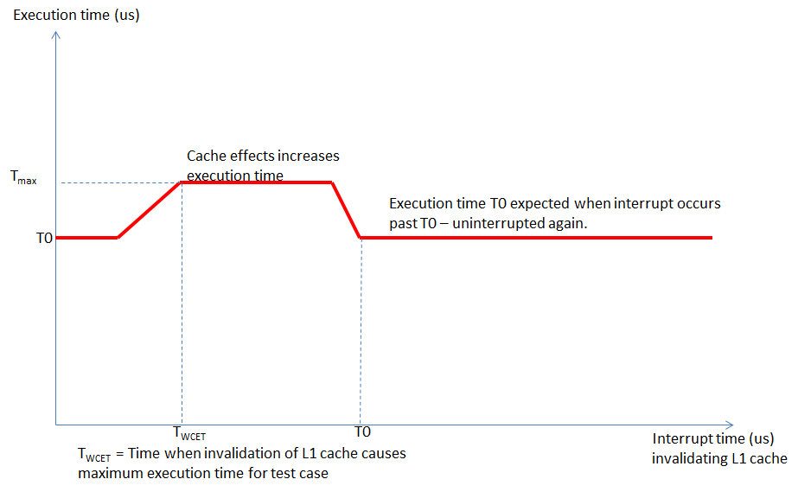

[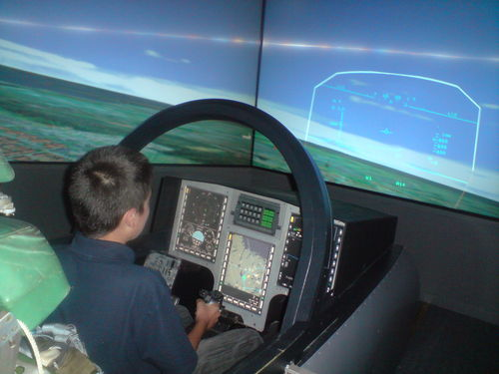](http://dani1993.buzznet.com/photos/default/?id=44867161#pt)For more details, see the full specification. **Challenging tasks**   
* Execute small applications uninterrupted by Linux in a small time-slot.  
* Force a cache invalidation/flush at a specific point in time.­  
  
**Requirements**  
* Linux kernel shall be 2.6.32, PowerPC e500v2.  
* Deadline for your solution is 2015-02-28.

**Prices**A flight in a SAAB Gripen simulator including a trip to Linköping, and accommodation.

**Benchmarking**  
Benchmarking is done using acceptance test found in full specification.

**The rules**  
Prize is limited to European residents.  
All submitted solutions must comply with GPL v2 license.  
The winner takes it all!

**How do I proceed?**  
Git clone from the following archive: https://github.com/linux-wcet/linux-wcet  
We accept solutions with git pull request to the git repo from 2015-02-25 to 2015-02-28.

**Questions?**See the [FAQ](http://tbd) on github.